|  |  |
| --- | --- |
| **Ivey Publishing Logo** | Temple University Logo |

9B21M019

APY Art Centre Collective: Taking Indigenous Art to the City

TL Hill, Sheri Lambert, and Kathryn J. Ready wrote this case solely to provide material for class discussion. The authors do not intend to illustrate either effective or ineffective handling of a managerial situation. The authors may have disguised certain names and other identifying information to protect confidentiality.

This publication may not be transmitted, photocopied, digitized, or otherwise reproduced in any form or by any means without the permission of the copyright holder. Reproduction of this material is not covered under authorization by any reproduction rights organization. To order copies or request permission to reproduce materials, contact Ivey Publishing, Ivey Business School, Western University, London, Ontario, Canada, N6G 0N1; (t) 519.661.3208; (e) cases@ivey.ca; www.iveycases.com. Our goal is to publish materials of the highest quality; submit any errata to publishcases@ivey.ca. i1v2e5y5pubs

Copyright © 2021, Ivey Business School Foundation Version: 2021-03-04

Skye O’Meara, manager of the APY Art Centre Collective, was preparing for a May 2019 meeting with the artists and elders on the Collective’s board. Prior to joining the APY Art Centre Collective, O’Meara had worked in various roles in the Indigenous art industry for over a dozen years (see Exhibit 1). She joined the Collective in 2017, and by 2018, was immersed in opening the Collective’s first gallery, in Sydney, more than 2,500 kilometres from the APY communities. Now, barely a year later, the board (see Exhibit 2) wanted to open another gallery, this one in Adelaide, in large part because Adelaide was closer to the APY Lands and a large contingent of APY community members lived in or visited Adelaide at any one time.

O’Meara shared the board’s excitement about starting a gallery that could also serve as an urban art centre for the APY community residents in Adelaide, and she was happy about the prospect of being closer to the APY Lands that she loved and visited monthly. At the same time, O’Meara was worried about the expansion. She had doubts about whether the small, isolated city of Adelaide could support a gallery: Would there be enough demand and donors? O’Meara was also concerned about whether she and her small staff could manage two galleries, thousands of kilometres apart, and still keep their ties to the APY Lands. On top of it all, O’Meara was developing a digital presence for the APY Gallery Sydney and was worried that opening a new gallery would distract her from building that presence. The board’s vision was certainly compelling, but was it practical?

APY Lands and Art

APY stood for Aṉangu Pitjantjatjara Yankunytjatjara, Aṉangu (pronounced *arn-ung-oo*) being Indigenous peoples of Australia.[1] The APY Lands were a parcel of land set aside for the traditional landowners from the Pitjantjatjara, Yankunytjatjara, and Ngaanyatjarra peoples. The Lands were in the north-west corner of South Australia, south of Uluru, near the centre of the Australian outback. In 2019, approximately 2,300 people lived on the APY Lands in approximately seven small communities spread over a vast area (see Exhibit 3).[2] Remarkably, each community had its own art centre.

In the late 1930s into the 1940s, the Australian government supported mission organizations in establishing settlements on the lands. The clans slowly settled into seven communities around the missions, although it wasn’t until the 1950s that the last clans settled down. Many of the elders on APY Lands had memories of the pre-contact period. Their parents spent most of their lives with no contact with the “whitefellas,”[3] and the elders themselves remembered both the “walking around time” (when clans were nomadic) and the early period of settlement.[4]

By 2019, the economic and health conditions on the Lands were dire. Sedentary life combined with poverty had led to significant health problems. Obesity was endemic due to a combination of food insecurity and the prevalence of poor-quality, high-calorie food. Alcoholism and violence were pervasive, and petrol sniffing was making a comeback despite the legacy of death and brain damage left by the previous wave of petrol sniffing in the late 1980s. Incarceration rates were extremely high, in part because of the poverty and substance-related violence and in part due to cultural rifts between the communities and the police. The widespread health problems resulted in many people from the APY Lands travelling to and living in Adelaide to receive medical treatment related to diabetes and associated kidney disease.[5] The need to seek treatment 1,400 kilometres from home resulted in isolation from families and communities, which only added to the stress and illness.

One of the few bright spots in this grim picture was art. Remarkably, approximately 500 active artists were on the APY Lands and most were working out of one of the art centres located in the communities. The art centres, such as Ernabella Arts, grew out of craft rooms set up in the missions; they provided art training, mentoring, and community (see Exhibits 4 and 5).[6] They also offered emergency financial support, often in the form of small jobs that might pay enough to cover a tank of petrol or food for a week. Over time, each community developed a distinctive style of art, but across the APY Lands, art expressed, preserved, and rejuvenated culture; generated continuity across generations; and provided one of the only sources of income independent of government assistance.

APY artists were a force in the Australian art world. For example, in 2017, APY artists accounted for 14 of 15 finalists for the AU$50,000[7] Wynne Prize, awarded annually for the best landscape painting of Australian scenery or for the best example of figure sculpture by Australian artists; two finalists for the $100,000 Archibald Prize, awarded annually to the best portrait painted by an Australian resident; and 25 nominations for the Telstra National Aboriginal and Torres Strait Islander Art Awards, Australia’s longest running and most prestigious Indigenous art awards.[8]

Nationally, a handful of recognized APY artists could command $100,000 or more for canvases, and established galleries in the big cities competed to showcase their art. For the other artists, distribution choices were few and risky because unscrupulous dealers travelled to Adelaide and the art centres to purchase canvases for tiny amounts, offering “day rates” of $20 or $100 for quick paintings, then re-selling the work without attribution, royalties or fees throughout urban Australia. Some dealers even set up painting sheds located in and around Alice Springs and paid young artists a few dollars a day to work in the painting sheds and create cheap reproductions of famous works.[9] O’Meara explained:

Carpetbaggers do not often come to the Lands; they lure artists into their sheds or sweat shops with a promise of fast income. They often exploit vulnerable, disadvantaged families living in extreme conditions, and they take advantage of the lack of numeracy and literacy skills and family social challenges.... Fake works are also produced in these sheds with artists being paid to copy works of higher profile artists.

APY Art Centre Collective

In response to these abuses, the APY Art Centre Collective was organized to create new markets, support region-wide collaborative art projects, and increase the money flowing to the art centres and the artists. The Collective was controlled by a board of elders, each elder representing a community art centre.

One example of an APY Art Centre Collective project was the canvas painted for and presented to the mosque in Christchurch, New Zealand, after the March 2019 massacre there. Elder, artist, and board member Nyunmiti Burton conceived the idea of giving a canvas after seeing television coverage of the massacre. She felt sad for the families and a connection with the spirituality of those in the mosque; she decided that the APY community needed to use its art to make a statement about the insanity of this kind of killing.

Reflecting on her inspiration, Burton spoke eloquently about “looking back to the time when we were strong—back when we walked around with no clothes—to find elements of our culture to become strong again moving into the future.” She was talking about making art, but art rooted in culture, stories, and oral and visual histories leading from water source to water source. She spoke about how all these elements were interconnected into one narrative, told and retold, painted, and repainted. But the artists did not just retell the old; they spoke of the current and future, using techniques and colours that made sense for the present.

Burton went on to talk about “sorry camps,” another cultural practice that had evolved. When someone died, the clan dropped everything and gathered in the desert for a week or more to mourn, tell stories, and bury their relative. A newer tradition involved placing yellow plastic flowers on the coffin and on the grave. These yellow flowers were a prominent feature of the canvas the APY Art Centre Collective gave to the Christchurch mosque.

The canvas was painted in a weekend by a group of women artists, old and young. After conversation about the massacre and the goal of the canvas, about sorry camps and grieving, about the connections they saw and felt, two or three of the elders painted the basic scaffolding—the black lines in the picture—and then the rest filled in the colours, each working on a small patch of canvas. Besides being a moving offering in and of itself, the finished painting was valued at well over $100,000 due to its beauty and the notoriety of some of the artists. It was an all-star canvas.[10]

Big City Lights

To circumvent the carpetbagger art dealers and support emerging artists, the APY Art Centre Collective decided to open its own gallery. The Collective’s goals were to command higher prices, build the reputations of emerging artists, protect them from unscrupulous dealers, and channel more money back to the APY Lands.

The elders envisioned not just a gallery space but an urban version of an art centre—a space that would provide support for the APY community members in the city, a communal studio, a launch pad for emerging artists, and an economic engine that would send money back to the APY Lands. The brick-and-mortar APY Art Centre Collective gallery would also provide a rich experience for art buyers by creating opportunities for customers to view and buy finished pieces and to learn about the art and its cultural roots from APY artists working on site. The gallery would educate customers and the broader community about APY art and about the workings of the market for Indigenous art. Finally, art buyers could be confident that the art they bought through the APY Art Centre Collective gallery was genuine and that the proceeds would provide financial support to both an APY artist and the APY community at large.

The elders asked O’Meara, a trusted “whitefella”, to represent the Collective and interact with the urban world. O’Meara had spent 12 years in the APY Lands, working at first for the government and later for various art centres. Although she had no dealer or gallery experience, O’Meara had proven to be a good administrator, a passionate advocate, and, critically, a trustworthy employee.[11] O’Meara estimated that about 200 rising artists had work that could be priced at $1,000 to $3,000 per piece if sold in an urban centre.

From the outset, the Collective was determined to challenge existing industry commission structures. Working with the elders, the Collective decided that the gallery would pay 60 per cent of the sales price to the artists and keep 40 per cent for operations; in addition, the gallery would channel any profit back to the art centres on the APY Lands. This payment structure was in marked and intentional contrast to the conventional gallery structure in which the gallery kept 60 per cent of the proceeds from the sale of the established artist’s work (see Exhibit 6). The Collective’s gallery fees were even further removed from the carpetbaggers’ practice of paying artists a small, flat fee and then keeping the entire selling price for the dealer.[12]

At first, the APY Art Centre Collective wanted to open its gallery in Adelaide, the capital of South Australia. South Australia was a sparsely populated desert state about the size of France, and approximately 1.3 million of its 2 million residents lived in Adelaide. Although Adelaide’s economy had suffered from the steep decline of automotive manufacturing in Australia, Adelaide remained the economic and service hub of the state with three universities, two large hospitals, a port, and a large number of small businesses. Adelaide was also familiar ground to the APY communities. While it was a two-to-four-day drive on dirt roads from the APY Lands in the far corner of South Australia, Adelaide was still the closest city of any size and was home to a constantly changing population of people from the APY communities, drawn to Adelaide for health care and economic opportunity. A gallery in Adelaide could do double duty as an art centre and place of support for the APY people navigating the city.

To fund the gallery dream, the Collective applied for government and private support while also raising seed money by producing and selling all-star canvases. After struggling to find enough philanthropic or government support to open in Adelaide, the APY Art Centre Collective received a donor’s offer to match the Collective’s seed money if the art centre would open its gallery in Sydney. Much larger and wealthier than Adelaide, the Sydney region had a population of more than 5 million residents, a diverse array of firms—many with global ties—and a burgeoning art scene. Further, Sydney was located in the state of New South Wales, the richest and most populous of Australia’s states. But Sydney was more than 2,500 kilometres from the APY Lands, and although it was home to an extremely diverse population, it had virtually no APY community. After painful deliberation, the board decided to take the risk, follow the money, and launch its first gallery in Sydney despite concerns about the distance and lack of APY community there.

APY Gallery Sydney opened in March 2018 in a two-story building, just blocks from the National Art School where artists visiting from the APY Lands could participate in professional development opportunities across a diversity of mediums, including printmaking, ceramics, sculpture, new media arts, and photography. Despite a rushed launch, scant initial notice from the art world, and the lack of an APY presence in Sydney, the gallery surprised everyone, including the APY Art Centre Collective, by selling $700,000 worth of artwork in its first year.[13]

Part of the gallery’s success was attributed to the occasional presence of the artists: gallery goers could interact with visiting artists making art. Also contributing to first year success was a concerted effort to reach art buyers through digital marketing techniques. The APY Art Centre Collective created a presence on the web, Facebook, and Instagram, and developed a mechanism for selling directly to buyers through direct messaging and email. The increased visibility also paid off indirectly with more APY artists winning awards, selling their art works at higher prices, and even being invited to travel internationally to display their work (see Exhibit 7).

By the end of its first year, the Sydney gallery had helped the Collective direct $941,000 to artists and the art centres on the APY Lands. However, as successful as the Sydney gallery’s first year was, the Collective remained reliant on donor support (see Exhibit 8). The gallery contributed to an increase in art sales from just over $913,000 in 2018 to just over $1,458,000 in 2019, but the cash proceeds from art sales contributed only $517,000 to cash operating expenses in 2019 of $1,076,000. The balance was made up from donated funds, especially government grants.

The success of APY Gallery Sydney sparked renewed interest in South Australia, and the state’s premier urged the APY Art Centre Collective to open a gallery in Adelaide. Because the Collective had always wanted to locate in Adelaide where so many APY people lived or visited for medical care, the elders were interested in the offer and asked O’Meara to move from Sydney to Adelaide to open a second gallery.

O’Meara was not so sure of the plan. Although the APY community was strong in Adelaide and many more artists would be able to work from a gallery located there, the Adelaide art market was tiny compared to that of Sydney. Also, South Australia’s capacity to support both art and Indigenous communities was much smaller than that of New South Wales. Further, the Sydney gallery was just finishing its first year, staffing was thin, and projected profits were uncertain. O’Meara worried that opening an Adelaide gallery would dilute attention, time, and money and increase the chance that the Sydney gallery, the digital marketing initiative, and the Adelaide gallery would all fail. Finally, the board had recently asked O’Meara to help several artists tour Europe and to organize a trip to Christchurch to present the sorry camp canvas. She was not at all sure that she could manage Sydney, Adelaide, digital marketing, and the tours, especially given the large distances involved and her commitment to the elders to spend as much as 40 per cent of her time on the Lands.

With all this in mind, O’Meara argued that she should stay in Sydney to develop both the Sydney and online customer base, using any extra time to work on special projects such as the tours. She was confident that in one or two more years, she could develop the gallery and its online store into a reliable source of income and reputation for the APY community. Once a strong foundation was in place in Sydney and online, the time would be right to open an additional gallery in Adelaide.

But the elders had been dreaming about a gallery in Adelaide for nearly a decade. A large APY community in Adelaide needed support, the state was interested in providing funding, and a gallery and workshop space were available. Further, while the Sydney gallery operations were shaky, its online presence was growing, and there was cash in the bank from previous fundraising, various special projects, and all-star canvas sales. The elders were adamant: it was time to launch the Adelaide gallery. O’Meara’s challenge was to make the expansion a success—without undermining the rest of the APY Art Centre Collective’s initiatives.

Exhibit 1: Biography of Skye O’Meara

Skye O’Meara started her work in the Indigenous art industry in 2003. She worked first for the Australia Council for the Arts, the federal government’s funding body for the arts, for four years before becoming manager of Tjala Arts in the Amata Community in 2007. During her years at Tjala Arts, she supported Tjala Arts directors and senior artists across the region to drive innovative artistic projects and strategies such as the Kulata Tjuta Project (Many Spears) and the APY Young Photographers program.

In 2017, O’Meara accepted the position of general manager of the APY Art Centre Collective. In that role, she coordinated and delivered an expansive range of prestigious artistic projects and regional business initiatives. Her passion was creating Indigenous employment in communities through art centres. Her self-described professional focus was “positive social change.”

Source: “Skye O’Meara,” W [Westpac] Scholars, accessed December 18, 2020, https://scholars.westpacgroup.com.au/Scholars/Profile?Id=3331; “Skye O’Meara,” LinkedIn, accessed December 18, 2020, www.linkedin.com/in/skye-o-meara-9234551a2.

Exhibit 2: APY Art Centre Collective, Board of Directors



Source: Company documents.

Exhibit 3: Location of APY Communities

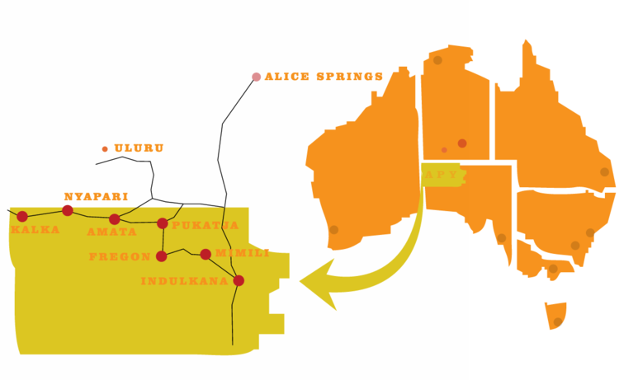

Adelaide

Sydney

Source: Company documents.

Exhibit 4: Ernabella Arts Centre Philosophy and Spirit

*I hear the singing and my mind takes me back to my life as a child when we didn’t know about your world. To a time where song was strong and echoed around our beautiful country, around the creek beds, rock holes and sand dunes of the Lands.*

*I am an old woman now. The songs of my childhood are still alive. There were years where we sang with softer voices, our voices were weakened from the challenges we faced when our worlds collided.*

*The job of the Elders became clear, and our focus grew stronger. Through our culture we would find the solutions. Through our culture we would find the opportunities and roles for the next generations.*

*We started our art centres first in Ernabella and then one by one in each of the communities. The song spread across the Lands. Together we sang and our voices became clear and strong, as strong as it was when I was a child. As we sing, we feel the spirit of the leaders we have lost beside us. Our voices crack and shake with pride for the new leaders who have followed in their footsteps, carry the song today.*

*And so the song continues*.

Nyurpaya Kaika, APY Artist and Board Member, 2017

Source: Company documents.

Exhibit 5: Learning by Doing at an Arts Centre

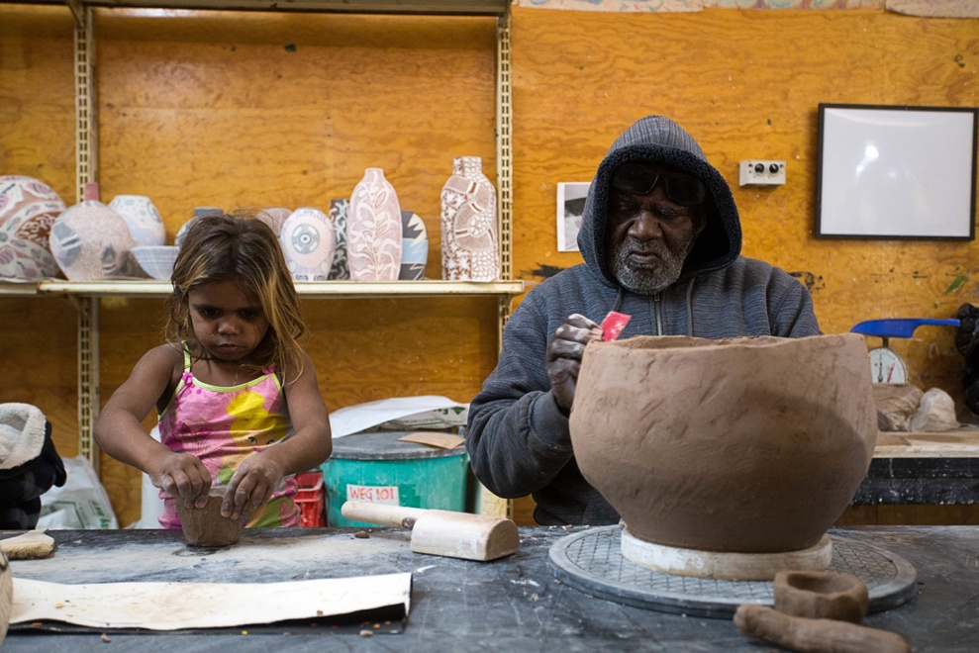

Source: Company documents.

-

Exhibit 6: APY Art Centres Versus Private Dealers

| **APY Art Centres** | **Private Dealers** |
| --- | --- |
| **Business Ownership and Employment** | **Business Ownership and Employment** |
| * 100 per cent owned and governed by Aboriginal people. * Income is returned directly to communities where it makes a significant impact on social challenges, according to strategic priorities set by community elders. * The goal of the art centres is to maximize income to the artists and to the APY communities. * Many individuals who live on APY Lands live below the poverty line, so “painting money is food money.” An artist’s income always goes toward feeding many family members, which is aligned with broader cultural value systems that prioritize shared resources and wealth. * The impact of the money returned to communities through art centres is far reaching. * In APY communities, art centres are the primary source of non-government income and the only “real” jobs that provide meaningful training, skill development, and pathways to sustainable employment. * APY art centres are accessible for participation by all community members. Art centres do not turn artists away. | * Predominantly owned by non-Indigenous people. * Do not prioritize Indigenous employment; the only Indigenous participants are artists. * The goal of the private dealers’ model is to maximize profit to dealers. * Private dealers often poach high-profile artists from community art centres and do little to support young and emerging artists. |
| **Financial Transparency and Accountability** | **Financial Transparency and Accountability** |
| * APY art centres work with full financial transparency. * Art centres are exposed to an independent financial audit annually, which is published on the Office of the Registrar of Indigenous Corporations’ (ORIC’s) website yearly. * Without these annual audits, art centres are not eligible to receive the government funding that supports art centre operations. * Art centres are also exposed to rigorous checks under ORIC, with staff regularly visiting APY communities to check financial reporting. | * Private dealers have no requirements for financial transparency and do not work with any formalized measures of financial accountability. |
| **APY Art Centre Staff and Best Practice** | **Private Dealer Staff** |
| * Staff are paid according to industry standards. * Staff are subject to performance reviews by industry peak bodies. * Staff do not receive bonuses based on the success of the business. | * Private dealer salaries are not required to align with industry standards. * Private dealers are not subject to industry standard review processes. |
| **Indigenous Employment** | **Indigenous Employment** |
| * In every APY art centre, there are 6–20 people working in support positions at the art centre each day. * In addition to income generated through the sale of artworks, art centres employ local Indigenous staff in many diverse roles, including studio support, drivers, interpreters, building and vehicle maintenance, administrative support, and cleaning. * Indigenous staff are supported with professional development and training opportunities across all areas of art centre operations. * Artists are also supported to travel to their exhibitions nationally. | * Private dealers do not support Indigenous employment outside of securing artists to paint for profit. * Private dealers do not offer training or professional development opportunities to Indigenous staff. |

Source: Company documents.

Exhibit 7: Social Media Traffic, 2018

| **Social Media** | **Traffic (Jan 2018)** | **Traffic (Dec 2018)** |
| --- | --- | --- |
| Instagram (@apy_ac_collective) | 27,000 | 40,900 |
| Facebook (www.facebook.com/APYCENTREHUB) | 10,200 | 13,267 |

Note: The Twitter account for APY Art Centre Collective (@apyacc) was not open until 2019.

Source: Company documents.

Exhibit 8: Financials for APY Art Centre Collective

Statement of Profit or Loss and Other Comprehensive Income, Year Ending June 30, 2019

|  | **2019 (AU$)** | **2018 (AU$)** |
| --- | --- | --- |
| **Income** |  |  |
| Revenue | 2,684,638.71 | 1,284,708.42 |
| Raw materials & consumables used | (941,226.40) | (575,796.36) |
| **Expenditures** |  |  |
| Accountancy expenses | (7,800.00) | (2,100.00) |
| Advertising expenses | (14,913.80) | (2,565.46) |
| Depreciation and amortization expenses | (16,851.75) | (3,981.00) |
| Employee benefits expenses | (276,805.70) | (173,700.36) |
| Freight and cartage | (54,575.85) | (5,041.21) |
| Other expenses | (786,791.71) | (274,733.31) |
| Profit for the year | 585,673.50 | 246,790.72 |

Exhibit 8: CONTINUED

Statement of Cash Flows, Year Ending June 30, 2019

|  |  |  |
| --- | --- | --- |
|  | **2019 (AU$)** | **2018 (AU$)** |
| **Cash Flow from Operating Activities** |  |  |
| Receipts from sales of art | 1,458,082.48 | 913,056.63 |
| Employment expenses | (266,854.04) | (164,882.82) |
| Receipts from donors and sponsors | 5,000.00 | 36,000.00 |
| Receipts from other sources | 3,909.09 | 1,063.64 |
| Payments to artists and art centres | (941,226.40) | (575,796.36) |
| Receipts from government and other grants | 1,060,709.09 | 551,635.45 |
| General administration and direct activities | (808,723.39) | (163,034.26) |
| **Net cash provided by operating activities** | 510,896.83 | 598,042.28 |
|  |  |  |
| **Cash Flows from Investing Activities** |  |  |
| Capital expenditure | (169,708.47) | (114,023.83) |
| **Net cash provided by (used in) investing activities** | (169,708.47) | (114,023.83) |
|  |  |  |
| **Cash Flows from Financing Activities** |  |  |
| Proceeds from borrowings |  | 49,000.00 |
| Repayment of borrowings | (8,497.63) | (699.51) |
| **Net cash provided by financing activities** | (8,497.63) | 48,300.49 |
|  |  |  |
| Net increase in cash held | 332,690.73 | 532,318.94 |
| Cash at beginning of financial year | 537,530.38 | 5,211.44 |
| **Cash at end of financial year** | 870,221.11 | 537,530.38 |

Note: These consolidated financials include the APY Gallery Sydney, the tours, and the sale of all-star paintings; they do not include information about the proposed Adelaide gallery.

Source: “Financial Report Updated (Lodged),” Documents for APY Art Centre Collective Aboriginal Corporation, February 7, 2020, accessed June 22, 2020, https://register.oric.gov.au/document.aspx?concernID=4242480.

1. “Anangu Culture,” Uluru-Kata Tjuta National Park, accessed December 18, 2020, https://parksaustralia.gov.au/uluru/discover/culture.
2. “Mullighan Inquiry—Commission of Inquiry Report (Children in State Care): Archived Website; Government Publication—2005–2008,” Trove, accessed July 3, 2020, <https://trove.nla.gov.au/work/192460885?q&versionId=210470728>; Edward P. Mullighan, *Children in State Care Commission of Inquiry: Allegations of Sexual Abuse and Death from Criminal Conduct*, March 31, 2008, accessed July 3, 2020, https://webarchive.nla.gov.au/awa/20080422032457/http://pandora.nla.gov.au/pan/83541/20080421-1221/mullighaninquiry/CISC+-+Complete.pdf.
3. “Whitefella” was a term used by Aboriginal Australians to refer to white or Caucasian persons generally, especially to differentiate the persons or their practices from those of Aboriginal Australians.
4. “Ernabella Arts: The Oldest Art Centre,” Ernabella Arts, accessed July 3, 2020, www.ernabellaarts.com.au.
5. Calla Wahlquist, “The Artists Painting Their Indigenous Songlines to Stay Healthy and Strong,” *Guardian*, October 16, 2017, accessed December 18, 2020, www.theguardian.com/australia-news/2017/oct/17/the-artists-painting-their-indigenous-songlines-to-stay-healthy-and-strong.
6. “Ernabella Arts,” op. cit.
7. All currency amounts are in AU$ unless otherwise specified.
8. Georgia Moodie, “Why the Remote APY Lands Dominate the Australian Art Scene,” ABC News, July 26, 2017, accessed June 18, 2020, [www.abc.net.au/news/2017-07-27/why-the-apy-lands-dominate-the-australian-art-scene/8746040](http://www.abc.net.au/news/2017-07-27/why-the-apy-lands-dominate-the-australian-art-scene/8746040); Linda Morris, “Record Number of Indigenous Artists in Wynne Landscape Art Prize,” *Sydney Morning Herald*, July 25,2017, accessed December 18, 2020, www.smh.com.au/entertainment/art-and-design/record-number-of-indigenous-artists-in-wynne-landscape-art-prize-20170724-gxhm8k.html.
9. Amos Aikman, “APY Artists Determined There’ll Be No Rip-Offs in Second Boom,” *Australian*, July 6, 2019, accessed July 3, 2020, www.theaustralian.com.au/nation/apy-artists-determined-therell-be-no-ripoffs-in-second-boom/news-story/d0fa7561cc515c9625e3394ffd5f7808; “APY Artists Open Gallery to Avoid ‘Carpetbaggers,’” YouTube video, 2:12, posted by “Steven Schubert,” September 2, 2018, accessed July 3, 2020, https://youtu.be/aAzxb1kblnU. The history of carpetbagging can be sordid; see, for example, Gabriella Coslovich, “Families Cry Foul over Artists’ Move,” *Sydney Morning Herald*, April 29, 2009, accessed July 3, 2020, www.smh.com.au/national/families-cry-foul-over-artists-move-20090428-am21.html.
10. For more detail about this canvas, see “APY Art Centre Collective,” Facebook, April 23, 2019, accessed October 20, 2020, www.facebook.com/APYCENTREHUB/posts/this-incredible-initiative-and-act-of-generosity-was-driven-by-nyunmiti-burton-f/2296448630410842/; Also, Aikman, A. “Token of grief for Christchurch and Tears for Sri Lanka,” *Australian,* April 24, 2019, accessed October 20, 2020.
11. After two hundred years of exploitation and oppression, Aboriginal trust was rare and hard-won, in large part because abuses persisted. For example, the chief executive officer of an art centre in Queensland was charged in 2020 with using his position for dishonest advantage, redirecting proceeds of art sales to his personal accounts. “Former CEO Charged with Ripping Off Aboriginal Artist and Art Centre,” Australian Government: Office of the Registrar of Indigenous Corporation, press release, May 22, 2020, accessed June 22, 2020, www.oric.gov.au/publications/media-release/former-ceo-charged-ripping-aboriginal-artist-and-art-centre.
12. Aikman, “APY Artists Determined,” op. cit.
13. Claudianna Blanco, “Opening of Aboriginal APY Artist-Owned Gallery in Sydney a Whopping Success,” NITV, March 27, 2018, accessed June 19, 2020, www.sbs.com.au/nitv/nitv-news/article/2018/03/27/apy-gallery-opening-first-aboriginal-art-centre-owned-gallery-sydney-whopping.